Commodore PET/CBM80xx/40xx Diagnostic User Port PCB **Rev. 0**

**Module Description**

# Introduction

The User Port PCB is part of the Diagnostic Clip project. Originally, it was made with a connector and wires, but since PCBs got cheap and provide interconnects very reproduceable with a low failure rate, it is a very simple board design.

The user port dongle/PCB connects the video signals and, IEEE Control signals and DIAGSENS & GRAPHIC to the GPIO pins of the user port. Further, it connects the tape read #1/#2 to the tape write signal. Not all user port signals are involved, so the user port is not completely tested.

|  |  |
| --- | --- |
| Pins | Connected Signals |
| 2-B | TVVIDEO - CA1 |
| 3-C | IEEESRQ - PA0 |
| 4-D | IEEEEOI - PA1 |
| 5-E-11 | DIAGSENS - PA2 - GRAPHIC |
| 6-7-8 | TPREAD2 - TPWRITE - TPREAD1 |
| 9-K | TVVERT - PA6 |
| 10-L | TVHOR - PA7 |

The source of the information, that was required to design this PCB was retrieved from <http://www.zimmers.net/anonftp/pub/cbm/schematics/computers/pet/diagnostics.txt>

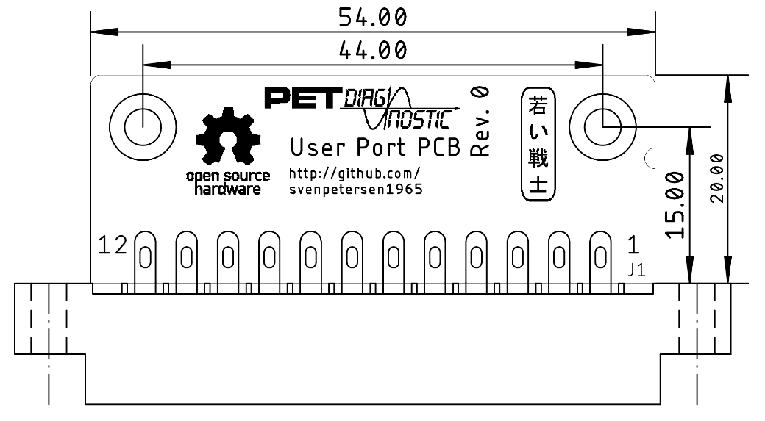

Figure 1: Dimensions of the User Port PCB

The 3D printable case requires two screws. Type C2.9 x 9.5 (DIN7981) self-tapping plastic screws are recommended.

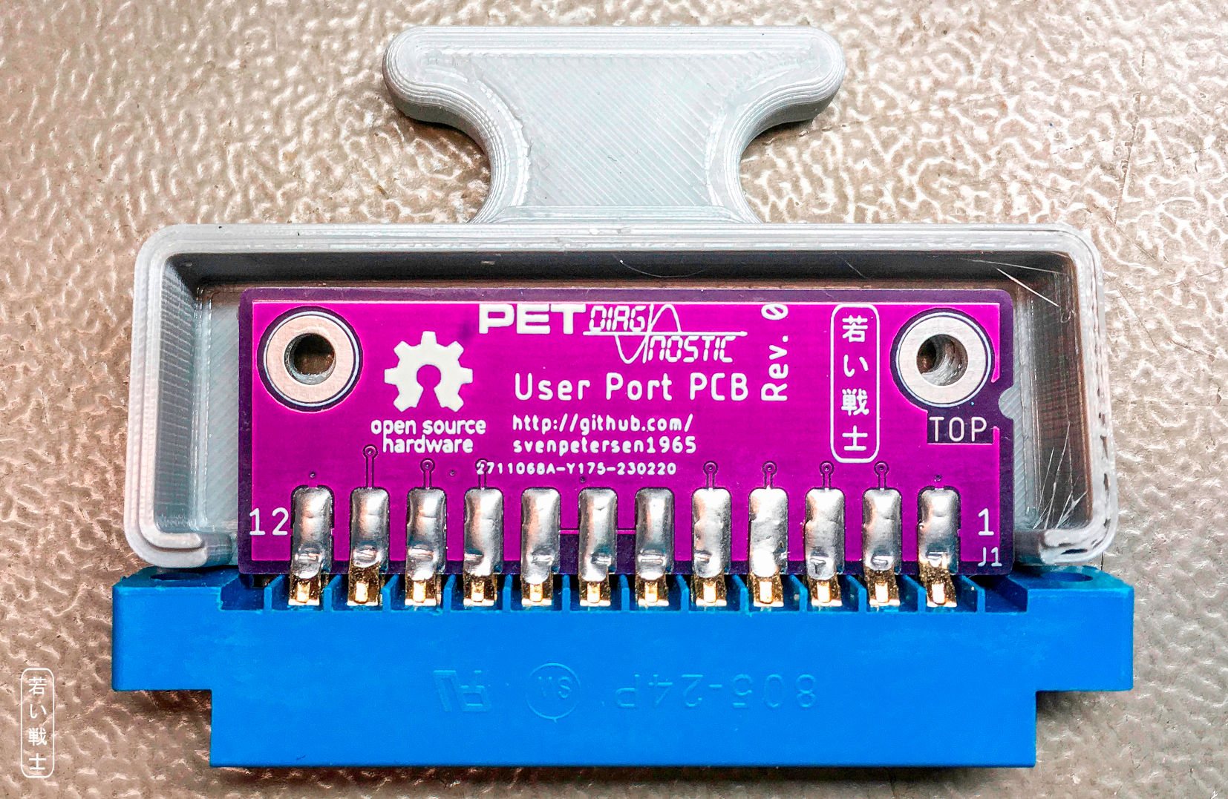

# Revision History

## Rev. 0

* Fully functional prototype